Five Year Weekly Betas of Sector Indices Against the S&P 500.

|  |  |  |
| --- | --- | --- |
| **Sector** | **Raw Beta** | **Adjusted Beta** |
| Utilities | 0.337 | 0.558 |
| Materials | 1.002 | 1.002 |
| Energy | 1.095 | 1.063 |
| IT | 1.161 | 1.108 |
| Communications | 0.752 | 0.835 |
| Financials | 1.121 | 1.080 |
| Consumer Staples | 0.661 | 0.774 |
| Consumer Discretionary | 1.026 | 1.017 |
| Industrials | 1.070 | 1.047 |
| Healthcare | 0.976 | 0.984 |

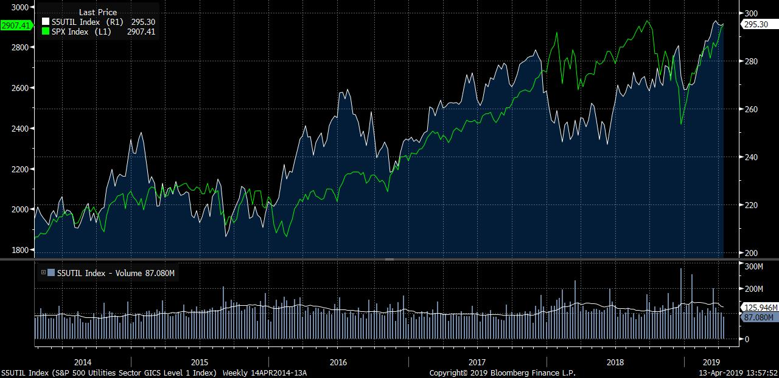

Communications Factors vs. Utilities Factors, 7 Year Effect Best Factors

|  |  |  |  |
| --- | --- | --- | --- |
| **Communications Factors** | **Effect** | **Utilities Factors** | **Effect** |
| 2Y Beta (Vol) | 285.49% | Book Value/Price (Value) | 98.13% |
| 5Y Asset CAGR (Growth) | 234.88% | Earnings/Price (BF1Y) (Value) | 95.19% |
| 1W Total Return (Momentum) | 217.18% | Fwd Earnings/Price (Value) | 91.99% |
| 2Y Fwd Sales Growth % (Growth) | 213% | E/P (FY2) (Value) | 85.13% |
| A/R Turnover (Working Cap) | 212.37% | Sales/Price (FY1) (Value) | 75.96% |

Worst Factors

|  |  |  |  |
| --- | --- | --- | --- |
| **Communications Factors** | **Effect** | **Utilities Factors** | **Effect** |
| Sales/Price (FY1) (Value) | -88.22% | Price vs 52W Low (Technicals) | -65.03% |
| Sales/Price (Value) | -88.20% | Price to Book Value (Multiples) | -52.99% |
| Net Debt/EV (Leverage) | -87.49% | 1W Total Return (Momentum) | -50.70% |
| 10Y Avg Operating Margin (est) (Profitability) | -85.93% | 14D RSI (Technicals) | -47.82% |
| PORT US Dividend Yield (Dividends) | -81.12% | EV/EBITDA (BF1Y) (Multiples) | -46.42% |

Correlation Between Communications and Utilities: 0.1863

